Project: Food Diary – Instructions for Using MyFitnessPal Food Diary
This project will familiarize you with using a food diary and analyzing the nutrient content of your diet.
Use the following information to help you when you use MyFitnessPal for your Three Day Food Diary.
Part 1. Food Diary
- Select a time frame when you are able to eat three meals a day because the tables must be complete – no skipped meals, at least one snack per day, and several drinks.
- Select three consecutive days for your food diary, and record the quantity of everything you eat and drink. Each day should have three meals, at least one snack, and several drinks.
- Include any condiments that you use with your meals or snacks.
- Be accurate when you record the quantity (serving size) of what you eat and drink.
- Write down what you consumed immediately (as soon as possible) after finishing your meal or snack. Completing your food diary as soon as possible following each meal or snack will increase the accuracy of your diary.

Part 2. Create a My Fitness Account
You may want to download an app for your IPad or Smart Phone. I use MyFitnessPal on my laptop and my iPad2 but I am unable to print from my iPad2.
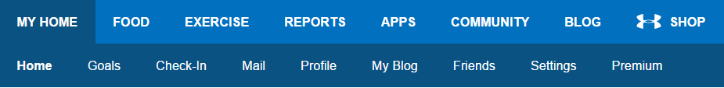

- Go to the following website: www.myfitnesspal.com/. Create your own account with a user name and password. You will need this information when you return to the website to complete your three day food diary.
- In the menu bar at the top of the website, click My Home and then Goals. (see above)
- Set up your profile in Goals:
Select “View Guided Setup”
Select “lbs” for weight and “ft,in” for height
This information will not be included in your project; however, it is needed for your diet profile.
Part 3. Using the Food Database and Analysis
- Click on Food in the upper bar. (see above)
- Click on Food Diary in the lower bar.
- Input your daily meals, snacks, and drinks for three consecutive days.
e.g.; click on Add Food underneath Breakfast
- Add food to Breakfast
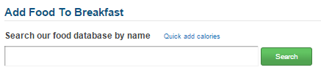

- Search food database
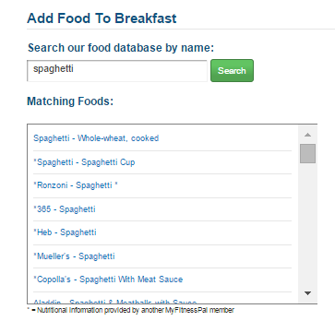
- Indicate your portion size using the drop-down window to the right of the list of Matching Foods
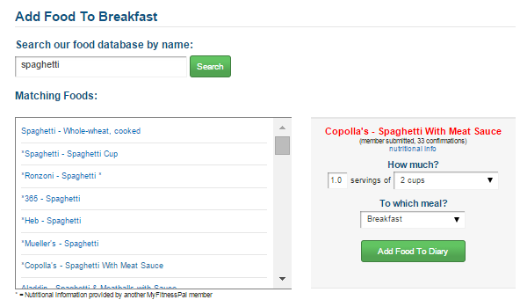

- Click Add Food to Diary to finish adding what you consumed for breakfast. Calories, sat fat, carbs, protein, sugar, and sodium will be calculated for each food or drink you add to your breakfast meal.
- After completing the entries for Breakfast. Click Add Food for your Lunch, Dinner, and Snacks. Follow the steps you used for Breakfast.
- Click Complete This Entry when you finished your entries for meals and snacks.
Daily totals can be found at the bottom of the daily food diary (log).

After you have completed a full day, copy and paste the table into your project document. There are four steps to obtain your table:
- Select “Complete This Entry”
- Select “View Full Report (Printable)”
- Select the table (include the date), copy, and paste into your document
- Use landscape orientation or decrease the size of the table to fit portrait orientation.

Here is an example of a complete table:

September 20, 2016
FOODS | Calories | Carbs | Fat | Protein | Cholest | Sodium | Sugars | Fiber
Breakfast
Splenda - Generic Splenda, 2 packet | 0 | 1g | 0g | 0g | 0mg | 0mg | 0g | 0g
Tea - Brewed, prepared with tap water (black tea), 2 cup (8 fl oz) | 5 | 1g | 0g | 0g | 0mg | 14mg | 0g | 0g
Panera - Plain Cream Cheese, 0.67 Tbsps | 33 | 0g | 3g | 1g | 10mg | 37mg | 0g | 0g
Panera Bread - Cinnamon Crunch Bagel, 1 bagel | 420 | 81g | 6g | 9g | 0mg | 430mg | 31g | 2g
Lunch
Fish - Tuna salad, 1 cup | 383 | 19g | 19g | 33g | 27mg | 824mg | 0g | 0g
Russell Stover - Pecan Delight, 1 pieces | 80 | 10g | 6g | 1g | 0mg | 18mg | 0g | 1g
Tea - Brewed, prepared with tap water (black tea), 1 cup (8 fl oz) | 2 | 1g | 0g | 0g | 0mg | 7mg | 0g | 0g
Splenda - Generic Splenda, 1 packet | 0 | 0g | 0g | 0g | 0mg | 0mg | 0g | 0g
Dinner
Aunt Jemima - Pancakes, 3 pancakes | 225 | 47g | 2g | 8g | 0mg | 675mg | 9g | 2g
Charlene Cary's - Syrup - Sugar Free, 0.25 cup | 30 | 12g | 0g | 0g | 0mg | 115mg | 0g | 0g
Blue Bunny - Mini-cones, 1 cone | 140 | 17g | 7g | 0g | 10mg | 60mg | 12g | 0g
Generic - Iced Tea, Unsweetened, 8 ozs. | 2 | 0g | 0g | 0g | 0mg | 10mg | 0g | 0g
Splenda - Splenda, 2 pkg | 8 | 2g | 0g | 0g | 0mg | 0mg | 0g | 0g
Snacks
Popcycle Sugar Free Popcycles - Sugar Free Popcycle, 2 POP | 30 | 8g | 0g | 0g | 0mg | 0mg | 0g | 0g
TOTAL: | 1,358 | 199g | 43g | 52g | 47mg | 2,190mg | 52g | 5g

